**SATURDAY 5th TRANSFIGURATION OF THE LORD (A)**

17:00 **Solemn Vigil Mass**

**SUNDAY 6th TRANSFIGURATION OF THE LORD (A)**

09:00 **Solemn Mass** *Our Parish Community*10:45 **Solemn Mass**

16:00 Eucharistic Adoration

**MONDAY 7th Feria**

*No Mass*

**TUESDAY 8th St Dominic, Pr**

**THE TRANSFIGURATION OF THE LORD (A)**

**6th August 2023**

Week beginning 23rd January 2022

**Sea Sunday**

**The Prophet Of God**

*No Mass*

**WEDNESDAY 9th ST TERESA BENEDICTA OF THE CROSS, V, M**

*No Mass*

**THURSDAY 10th ST LAWRENCE, Deacon, M**

*No Mass*

**FRIDAY 11th St Clare, V**

*No Mass*

**SATURDAY** **12th Feria**

*No Mass* *at 12 noon*

17:00 **Solemn Vigil Mass**

**CONFESSIONS** are heard on Saturdays from 11:15-11:45 or by appointment.

**Chantry List for the coming week:** We pray for the happy repose of the souls of all the faithful departed, especially for those whose anniversary of death occurs at this time: *Michael Mahoney (10); Arnold Otter (03); Ronald Allen (94); Ann Hytch (00); Kathleen Teahan (95); Edward Finch (06); Peggy Tiernan (07); Audrey Brown (84); Jocelyne Bohen (88).* ***May they rest in peace. Amen.***

**Our prayers for the Sick & Suffering include:** Angela L, Barry S, Kerri H, Betty B, Maura G, Sid B, John F, Gary R, Lily Dopson, Marjorie S, Elaine S, Genette F, John W, Teresa H, Noel K, Dean K, Christopher D, Peter W, Gina O, Carmelo S, Samantha B, Jenny C, John, Isaac Nelson, Ann Mary B, Brian B, Kay Shaw, Grace Gosling-Campbell, Joan Kerins, Beth Thompson, Jenny Crane; Evelyn Korinth.

**CONTACTS**:

**Parish Priest – Fr Jon Ravensdale:**

21 Blackthorn Ave, Colchester, CO4 3QD – **** 01206 870460

e-mail: [greenstead@brcdt.org](mailto:greenstead@brcdt.org%20)

**Web Site**: [www.stjohnpayne.org.uk](http://www.stjohnpayne.org.uk)

**Newsletter Editor** – *Lindsay Francis*:[greenstead@brcdt.org](mailto:greenstead@brcdt.org)

**Lay Pastoral Assistant** – *Ann Roughan* – **** 07889101762

**Hall Administrators** - *Tom and Mary Smith* –**** 07890540056

**Safeguarding Reps** –*Ann Bates* – **** 863067: [ann.bates36@btinternet.com](mailto:ann.bates36@btinternet.com)

*Lindsay Francis -*  **** 07977917554

**Health & Safety Rep** – *George Bulmer*– **** 870460

**The Canonesses:** 74, Howe Close, Colchester, CO4 3XD – **** 867296

*Brentwood Diocesan Trust Registered Charity No. 234092*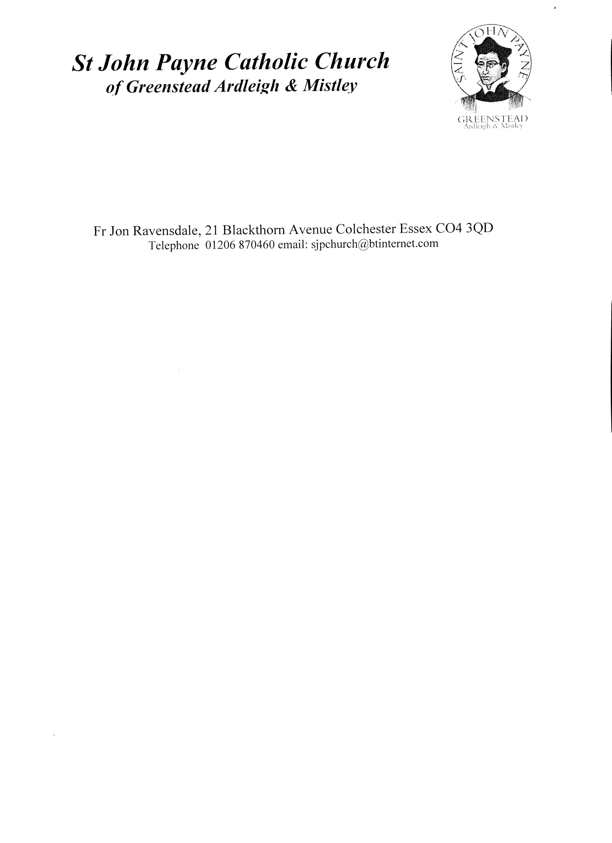

**St John Payne Catholic Parish**

Greenstead, Ardleigh and Mistley

*We of St John Payne Catholic Parish seek to reflect the joyful life-*

*affirming power of Christ’s Living Presence among all where Essex meets East Anglia.*

It is wonderful for us to be here today as we celebrate the transfigured Christ, the Christ of prophecy, in whom we have believed.

*Entrance Antiphon: In the shining cloud the Spirit is seen; from it the voice of the Father is heard: This is my Son, my beloved, in whom is all my delight. Listen to him.*

*1st Reading:*

Daniel 7:9-10.13-14 His robe was white as snow.

*Responsorial Psalm R/.* ***The Lord is king, most high above all the earth.***

*2nd Reading:*

2 Peter 1:16-19 We heard this ourselves, spoken from heaven.

*Gospel Acclamation R/.* ***Alleluia, alleluia!***

*This is my Son, the Beloved, he enjoys my favour; listen to him.*

*R/.* ***Alleluia!***

*Gospel Reading:*

Matthew 17:1-9 We heard this ourselves, spoken from heaven.

MCj04298950000[1]***We respectfully ask that you please ensure that all mobile phones are switched off while you are in church.***

**THE POPE’S INTENTIONS FOR AUGUST:** that the World Youth Day in Lisbon will help young people to live and witness the Gospel in their own lives.

**EUCHARISTIC ADORATION:** Every 1st Sunday of the month between 4 – 5pm, beginning with Evening Prayer, we have a Holy Hour of hymns, prayer, and readings before the Blessed Sacrament, *'the source and summit of our faith'.*  Next Date: **Sunday 6th August 2023.**

**LECTIO DIVINA PRAYER GROUP** **meets** **every Tuesday**, in the SJP Church Hall, from 10.00 – 10.45. Come and join this friendly group as we pray one of the readings for the following Sunday. Copies of the reading are supplied. There is usually a bit of social time afterwards. For further information see Judy after Mass or tel. 07530956440.

**WOULD YOU VALUE SOME FRIENDLY SUPPORT DURING A TIME OF LOSS OR EMOTIONAL ANXIETY?** Confidentiality will be respected. If you are interested in finding out more why not drop into SJP Church Hall on the **second Wednesday of every month**, between 10.30-11.30 a.m., or phone Judy on 07530956440

**PRO-LIFE COFFEE MORNING**: You are warmly invited to a coffee morning on Tuesday 8th August, 10.30am-12.30pm at the home of Clare Fox, Cherry Tree Farm, Bromley Rd, Ardleigh CO7 7SG. Come and enjoy a morning of tea, coffee and cakes with the opportunity to raise funds for and find out more about the life changing work of March for Life UK.

**COLCHESTER FOOD BANK:** As food price inflation and the cost of living crisis continues to disproportionately affect the poorest, the Foodbank has run out of or is critically low on the following items: Shampoo/conditioner; soap; washing up liquid; nappies sizes 5, 6 and 7; deodorants; toilet rolls; soups; tinned fish; pasta sauce; tea bags 80’s; coffee; rice; pasta; tomato ketchup; peanut butter / chocolate spread / jam. The next collection from SJP will be on **Sunday 13th August**, or you can donate at any time: just call me on 07582 502188. Thank you! James

**COULD YOU BE A VOLUNTEER FOR THE REFUGEE CHARITY CALAIS LIGHT?** We’re recruiting NEW volunteers to support refugees in two North Essex bridging hotels. Volunteer activities are open to anyone from chatting with refugees to playing board games, going for local walks, teaching English (spoken & written) and orienting them to life in the UK.

**Volunteers can help weekly or fortnightly, to find out more please contact the Lead Volunteer, John Bradley at:**[**johnbradley9255@gmail.com**](mailto:johnbradley9255@gmail.com)

If you are able to support financially, please donate via the website:

[www.calaislight.com](https://www.calaislight.com/)

**PARISH EMAIL ADDRESS *– PLEASE NOTE THE EMAIL ADDRESS HAS CHANGED*:** Please send **all** correspondence, and Newsletter items (by Wednesday evening) to: [greenstead@brcdt.org](mailto:greenstead@brcdt.org)

**OFFERTORIES:** Week ending 23rd July: Offertory £225.56. **Thank you!**

**COULD YOU DONATE TOOTHBRUSHES & DISPOSABLE RAZORS FOR REFUGEES?**

Founded in 2017 after the demolition of ‘The Jungle’ refugee camp in Calais, Roots, a charity based in Dunkirk, provides displaced people with essential basic services such as drinking water, hot showers, waste management and access to electricity. Calais Light has sourced deliveries of toiletries from corporate donors for Roots, but none have offered toothbrushes or disposable razors, which are now really needed. Roots has plenty of toothpaste! Could you add a pack of disposable razors and / or a couple of toothbrushes to your weekly shop? Calais Light will then ensure that they are delivered to Roots in Dunkirk. Please telephone Lindsay Francis on 07977917554 for more information, or see Lindsay or James after mass. Many thanks!

**THE CATHOLIC POLICE GUILD** **100th ANNUAL REQUIEM MASS:** Westminster Cathedral 7th November at 2pm.  Bishop Alan will preside. The Mass is held every year for all deceased Police Officers and staff.

**NEW HALL SCHOOL IS OFFERING OPPORTUNITIES FOR PLACES IN RECEPTION TO YEAR 3 FOR PRACTICING CATHOLIC FAMILIES FROM SEPTEMBER 2023:** New Hall School was founded by the Canonesses of the Holy Sepulchre and our Catholic foundation is at the heart of our ethos, building a Christian community in which all are welcome. The School Chapel has been a sacred place of worship for over 200 years, and we continue to welcome students into the faith through regular liturgies.  Our Chaplaincy Team, led by Fr Martin Hardy, guides our students through their faith journey and offers the opportunity to nurture their relationship with God through both our First Holy Communion and Confirmation programmes. For more information, please contact Caroline Elder at <c.elder@newhallschool.co.uk>

**STALLHOLDERS NEEDED FOR CHRISTMAS CRAFT & GIFT FAIR:** The Brentwood Catholic Children’s Society are seeking stallholders for their Christmas Craft and Gift Fair being held at The Mill Hall Arts & Events Centre, Bellingham Lane, Rayleigh SS6 7ED on Sunday 5th November from 10.30-4pm.Pitches are**£30** and all profits made on the day are the stallholders’ own. For further information please contact Damian: [ddillon@bccs.org.uk](mailto:ddillon@bccs.org.uk) / 07912 308000

**View Parish Newsletters online at:**

<https://stjohnpayne.org.uk/newsletter>**.**